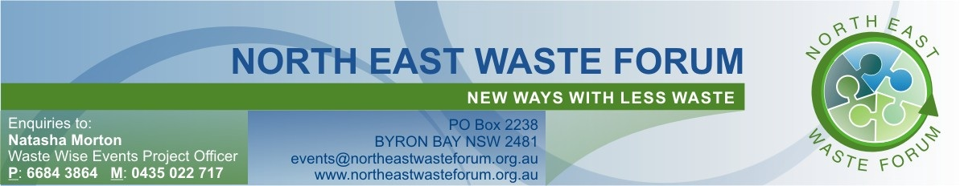

Waste Wise Management Plan for Special Events
Local councils on the North Coast with the assistance of the North East Waste Forum are working with events to achieve waste reduction and recovery and improve planning of waste management at events.

The NSW Government has produced a Toolkit which is available online which will assist event organisers complete this form. Look for the Waste Wise Events links at www.environment.nsw.gov.au

1. EVENT DETAILS

Name of Event

Date | From: |  | To:
Time | From: |  | To:
Venue

Organisation Staging Event
Anticipated Crowd Size
Event Activities

Existing Facilities (toilets, bins, shed etc)

Number of participating Stallholders | Food: | Drinks: |  | Other

2. CONTACT LIST

Name | Role/Position | Phone
 | Event Organiser
 | Waste Manager

3. STALLHOLDER WASTE
Activity | Product: Food or Drink Type | Materials Generated | Recyclable? | Quantity | When produced?
Eg. Juice Stall | Smoothies  Juices  Coffee | Fruit and vegetable pulp  Milk containers  Soy milk containers  Yogurt containers  Cardboard boxes | No  Yes  No  Yes  Yes | 30kg  30  30  12  15 | During  During  During  During  Before

4. BIN STATIONS (RECYCLING BINS, WASTE BINS and SKIPS)
How many Bin Stations are required for public use? (Use Attachment 1 for calculating or leave blank for Council guidance))

What bins are required for stallholder waste? (Use table above and Attachment 1 or leave blank for Council guidance)

When will bins be delivered?

How will equipment be secured?

When will bins be emptied?

When will bins be removed?

Highlight bin stations on event site map and distribute to stallholders?

5. PROMOTIONAL ACTIVITIES

Action | Date/Time | Who | Done (tick)
Letter to Stallholder. Letter/guidelines outlining packaging requirements and recycling facilities available
Write media release and issue to local media
Arrange council event bins which are provided with bin signage. Ask council for additional signage for skips if required.
Arrange for council Waste Wise Event banner
Prepare script announcement for PA
Ask local council to promote recycling at the event by booking the Greenhouse Performance Trailer

6. WASTE MANAGEMENT SET UP ON THE DAY OF THE EVENT

Action | Date/Time | Who | Done (tick)
Attach signage to skips (if required)
Position bins according to the bin site plan. Bin stations should include one recycling and one waste bin.
Cover existing street bins or ensure recycling bins are located next to street waste bins
Monitor stallholders as they set up. Ensure they are aware of recycling locations
Install banners and other signage

7. WASTE MANAGEMENT DURING THE EVENT

Action | Date/Time | Who | Done (tick)
Monitor bin stations… empty when full and ensure bins stay together in their stations
Monitor stallholder waste and ensure they utilise facilities correctly

8. WASTE MANAGEMENT AFTER THE EVENT

Action | Date/Time | Who | Done (tick)
Collecting bins and emptying into skips
Continue to monitor stallholders as they pack up
Site clean up
Thanking the waste team
Monitoring contamination
Evaluation
Reporting to event organising committee

OFFICE USE ONLY

9. COUNCIL APPROVAL
Waste Officer

Contact ph |  | Mobile
Waste Plan Approval Granted |  |  | Date

10. EVENT EQUIPMENT REQUIREMENTS
No. | Size | Equipment Type | Target Materials
 |  | Skip | Cardboard/ Paper
 |  | Skip | Plastic Bottles/Aluminium/Glass/Paper Cups
 |  | Skip | Waste
 | 240L | Event recycling bins | Plastic Bottles/Aluminium/Glass/Paper Cups
 | 240L | Event waste bins | Waste
Additional notes:
- All contents of wheelie bins must be tipped into skips and left empty for pick up.

