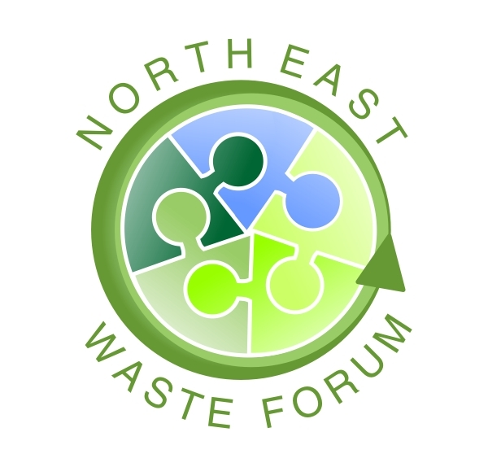

Waste Audit Procedures
A waste audit is a formal, structured process used to quantify or measure the amount and types of waste being generated by an organisation or residence. Information from audits will help identify current waste practices and how they can be improved.

Waste audits need to be carefully planned and the safety of people conducting the audit is paramount. Sorting is done in ventilated areas and is carefully controlled. Sorters undertake safety training and use protective equipment such as tongs, gloves, masks and overalls. Waste is never handled with bare hands.
Basic equipment for audits

A well ventilated, sheltered work area Water and cleaning equipment
A surface to put waste on Plastic sheeting to cover tables
Buckets of different sizes Tongs and rakes to sort waste
Accurate scales or containers Data sheets
Garbage bags Safety equipment and First Aid kit

Before starting your audit it is important to: have permission from management, inform your staff of OH&S and confidentiality issues, and keep the date of the audit unknown by the people you are auditing.:
STEPS TO CONDUCTING A WASTE AUDIT

A) PLAN
- COLLECT
C) SORT
D) ANALYSE

A). PLAN the audit carefully and define the study area
Good planning is essential. You will need to get management support, define the objectives of the audit, organise people and deal with other issues raised as a result of the audit.

Step 1 Define study area and set objectives | - Determine location(s) to be audited  - Determine types and approximate quantities of waste to be audited
Step 2. Collect background information | Visit location(s) and record:  - number of employees in study area  - number, types and locations of bins  - types of waste seen  - who empties bins and when
Step 3. Prepare for the audit | - Collect auditing equipment  - Brief/train cleaners and sorters  - Finalise waste collection details  - Double-check locations of bins

B). COLLECT the waste from the study area

Cleaners or waste contractors can collect the waste for you. You will need to talk to building managers and cleaning supervisors to get their support

Step 1 Collect the waste | - Collect all waste daily  - Label bags showing location and day  - Record relevant collection details
Step 2 Transport the waste to the sorting area | - Store waste on-site if possible  - Otherwise transport to secure location using a licensed transporter

C). SORT the waste into different categories and record the data

After the locations from which the bag of waste comes is recorded, the bag is emptied onto the table and sorted into material categories (e.g. glass, office plastics, metal etc.). Each category is then individually weighed or measured and recorded. If scales are available each category can be weighed. If not, measure categories in buckets and record volumes. 9 litre buckets and 20 litre containers are commonly used. The table is cleaned and the sorted waste disposed of, and the process is repeated for the next bag and so on.

Step 1 Prepare the sorting area | - Cover tables with plastic  - Set up tables and scales  - Collect buckets, bins, brooms, etc.  - Have water and first aid kit on hand
Step 2 Sort the waste | - Carefully open bag and spread waste  - Sort into different material categories  - Count or weigh individual materials  - Record findings on data sheet  - Dispose of sorted waste  - Repeat for all bags
Step 3 Final clean up and decontamination | - Dispose of sorted waste  - Clean off tables  - Clean buckets and other equipment  - Sweep and disinfect floor  - Shower and change clothes

D) ANALYSE the data and write up the results

Once all the waste is sorted you will have a large number of data sheets showing the quantity of waste by material categories that was generated within each area sampled. Once analysed the results can be written up and recommendations made.

Step 1 Enter and analyse the data | - Enter data sheets onto spreadsheet  - Do calculations
Step 2 Prepare an audit report | - Prepare audit report, including findings and recommendations
This information is adapted from the Department of Environment and Conservation WRAPP Fact Sheets at http://www.wrapp.nsw.gov.au/factsheets/factaudit.shtml

