COMPOSTING WITH ‘THE GREEN HOUSE’ LESSON PLAN

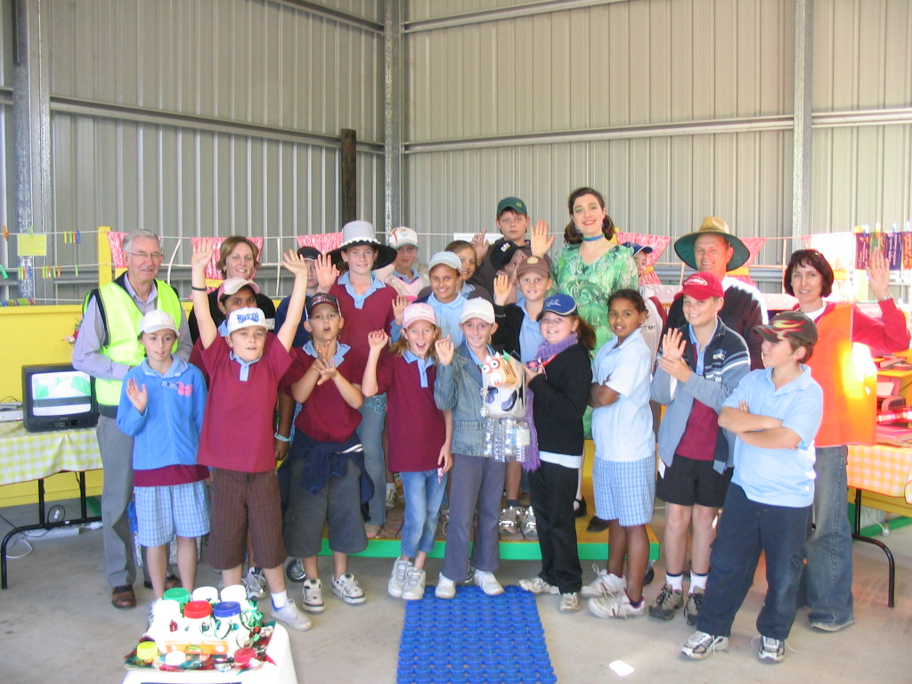
Around 50% of household and 30% of schools waste consists of organic waste – i.e. food scraps and garden waste which could be composted. Organic waste that’s sent to landfill generates methane, a greenhouse gas that’s 20 times more greenhouse-intensive than carbon dioxide. The average Australian household produces about 700kg of greenhouse gas emissions from food and garden waste each year, about half from each. By composting food waste (or using a worm farm), the average household could reduce their greenhouse gas emissions by about 300kg.
There are a number of strategies that students could do at school and at home to reduce the amount of organics which end up in landfill. This lesson helps participants to develop strategies to manage a school's organic waste (i.e. Food scraps and garden waste) through introducing the concepts and theory of composting and worm farming.

It is intended that the schools should/can book The Green House or arrange for a Council visit for practical composting and worm farming. Contact greenhouse@northeastwasteforum.org.au or your local council for further assistance. The following session outline can be conducted by a teacher or student who has prior knowledge of theoretical and practical composting. Curriculum links for NSW Primary and Secondary schools appear on the last page.
North East Waste Forum

www.northeastwasteforum.org.au

To book The Green House contact greenhouse@newaste.org.au

Incorporating Ballina Shire, Byron Shire, Richmond Valley, Lismore City, Clarence Valley, Kyogle and Tweed Shire Councils

LESSON AIMS AND OBJECTIVES

Introduction to Composting: (1 hour)

Outcomes:

At the end of the session, participants will:
- Know how to build a compost heap
- Understand a range of different composting styles
- State solutions for reusing food waste in the home and at school
- Understand how composting reduces waste
- Understand how composting reduces our negative impact on the environment

Key Messages:

The session aims to cover the following key messages:
- Composting is a key factor in reducing waste in the home and at school
- Composting is simple (at home) and can be achieved in a variety of ways
- Composting at school will required prior planning and assistance from other organisations – can concentrate on one particular area – eg. canteen

Resources:

- Finished compost
- Composting materials (in small tubs)
- Compost bins – full size and smaller container for building compost heap
- Information sheets
- Live worm farm for interested participants

Preparation:
- Contact Waste Education Officer at Council for any giveaway opportunities
- Encourage group to involve children if possible
- Check number in group
- Check facilities at venue

LESSON STRUCTURE

Time | Script | Presentation, Resources
5mins | Introduce yourself:  Introduce the presentation:  This presentation is aimed at reducing the amount of waste produced which ends up in landfill through strategies such as composting and worm farming  State the outcomes of the presentation. At the end of this presentation you will:  - Know how to build a compost heap/system  - Understand a range of different composting styles  - state solutions for reducing waste in the home  - understand how composting reduces waste  - understand how composting reduces our negative impact on the environment
10mins | Waste Generation  Our current waste generation practices are of concern, as we are very quickly running out of landfill space.  Current disposal practices  Each person generates about 1 tonne of garbage per year – about the same height and width as a family car. Around 50% of this household waste is organic waste – i.e. food scraps and garden waste which could be composted. (in a school – approx 30% is organic).  The waste management sector generates 4% of Australia’s greenhouse gas (GHG) emissions, including 13% of total methane emissions, mostly from disposal of waste to landfill (Australian Greenhouse Office 1999).  Problems with current rates of disposal  There are many ways that residents are already reducing waste.  - Buying items in bulk  - Taking their own bags to the shops  - Reusing materials more than once  - Recycling paper, plastics etc at home  Most people are keen to reduce waste going to landfill, but as individuals and a community we can do more to make a difference.  Take a look at an average schools waste – ask students what they can see in the graph. Approx 30% is made up of organics. If you are not composting all this valuable material is being buried in landfills where it is useless.  Many people think that green waste in landfill is O.K. – that it breaks down and creates good soil that helps the environment. This is not what happens however. The lack of air in a landfill means that nothing much breaks down at all. Landfill sites have strict controls to keep them safe and contained so that they do not affect the surrounding environment. Once waste is added to the tip face, heavy compaction bulldozers compact the waste to maximize the space. In NSW the tip face must be covered every day with a layer of earth. All our waste materials, tightly compacted and covered with soil, therefore sit in the soil, where there is very little or no air. The organisms that break down food and garden waste require aerobic conditions – that is the presence of air to survive. Food and garden waste sent to landfill will not break down into soil or compost.  Organic waste that’s sent to landfill also generates methane, a greenhouse gas that’s 20 times more greenhouse-intenstive than carbon dioxide. The average Australian household produces about 700kg of greenhouse gas emissions from food and garden waste each year, about half from each. By composting food waste (or using a worm farm), the average household could reduce their greenhouse gas emissions by about 300kg.  As food and garden waste are the main materials left in our garbage, after avoiding, reusing and recycling, the next step in reducing our waste is to divert our food and garden waste from landfill through composting. | Show photos of landfill  Show examples of reuse (calico bag, glass jar for storage etc)  Show graph of schools waste (available in Schools Waste Fact Sheet – www.northeastwasteforum.org.au - A_Z of Waste)
5mins | The importance of composting  Food and garden waste can be easily turned into compost. Composting:  - Reduces waste in your bin and therefore waste to landfill  - Can be undertaken by anyone – even in small spaces  - Processes kitchen scraps and garden scraps into a natural fertilizer for pot plants and/or your garden  - Is easy to set up and maintain  Who should compost?  Anyone can establish a compost as there are a number of ways to do it:  - Building a heap  - Using a commercially made compost bin  - Using a worm farm  - Using a Bokashi Bin  - Building a communal compost – for people who live in units  - Joining a community garden  What is compost?  Compost is decomposed organic matter (anything that was once living). | Show pictures of different types of composting systems – tumbler, bin, heap, 3 bay system.  Show finished compost.
5mins | Four Steps to Composting – the ADAM Principles  Everything you need to know about composting can be related back to the following four principles:  1. ALIVENESS – a compost system is a living system  2. DIVERSITY – feed your compost a mix of materials for best results  3. AERATION – the microorganisms in your compost need to breathe, so turn the compost regularly and use twigs or shredded cardboard/paper to allow air to flow through  4. MOISTURE – the compost needs to be moist – about the same as a wrung out sponge | It might be useful to write these on a board if there is one available, so that you can refer back to it later.
15mins | Four Steps to Composting -  1. Choose your compost site  Whether you decide to build a heap or use a commercial compost bin, you should do the following:  - choose a location that is well drained, warm and sunny.  - place it on soil so that worms and microorganisms can enter and water can drain through.  - choose a site that is easy to access, so that you are more likely to use it.  - For schools – as it will be used principally for the canteen waste, think about access to the canteen.  2.Add your materials  The following will ensure that your compost stays healthy and avoids any of those nasty smells!  - Establish a flow of air by building a bottom layer of coarse materials (eg twigs, prunings, torn up newspaper). This will allow air to flow through the compost, giving microorganisms the air they need to survive and break down the materials.  - Add a layer of microorganisms – throw on a layer of finished compost or soil to introduce microorganisms  - Anything that was once living (plant or animal) can be added  - ‘Green’ (wet) materials: grass clippings, food waste, hair  - ‘Brown’ (dry) materials: vacuum cleaner dust, shredded newspaper, twigs, dry leaves  - next time you clean out the gutter, add the contents to your compost, as it often consists of leaves, grass and soil – it will stop these from ending up in the stormwater drain and in our waterways  3.Layering  The secret to successful composting is to vary the layers and materials that you add to the compost.  - the first layer should be of coarse material to ensure a flow of air through the compost heap.  - next alternate between a layer of greens and browns  - Each time you add food waste add a layer of brown  - If adding dry materials, you may need to add water  - Except for the first layer of coarse material, keep layers thin, to assist the break down process and allow water to move through the system  - Place a cover of thick wet newspaper after all the other layers, then top it off with a cover of carpet underfelt (natural fibre) or a hessian sack (to help keep moisture in and allow air to move through the system)  4.Turning  To encourage decomposition of all the layers you should turn the compost regularly – every two to three weeks. Turning your compost helps to avoid problems that result if it is too dry or too wet.  Compost can take anywhere from about 8 weeks to mature, depending on individual circumstances. | Ask some of the students where they have their compost at home  Explain that you are going to build a ‘mini-compost’, to show the steps in layering., as you speak.  Point to the sample materials in each tub as you explain green and brown.  Physically show a layer of about 10centimetres for the coarse layer.  Other layers should be about the width of your palm.  Show a sample of carpet underfelt and hessian (many Local Councils sell these bags and often fruit and vegetable shops have them).  Hand around some finished compost.
10mins | Trouble shooting/problems  1.It’s too far away  - Keep a kitchen tidy in your kitchen to store food scraps on a daily/two day basis. An ice cream container is perfect – just make sure the lid seals.  2.It’s too hard  - Take out the compost materials when you take out your garbage and recycling, so that it becomes routine  - Build the compost in a site where you can get to it easily  - Keep all the tools you will need (gloves, garden fork, watering can) together in one place for easy access  3.It breeds cockroaches, ants and other creatures  - Turn the compost to avoid drying out  - Keep a cover of hessian to help maintain the moisture content  - The compost is a living system, so there will be some unexpected visitors. Remember, if they are not taking over the compost, they are helping the system to work properly.  4.What about rats and mice  - They will be attracted to the food  - Place a thick wire mesh under the compost before building  - Wrap food scraps in newspaper before placing in the center of the compost. Then surround this with grass clippings  5.What about meat, seafood and other problem materials?  - Meat, seafood and dairy will break down if the temperature in the compost is high. For beginners it is best to leave these out.  - Manure – can contain active weed seeds (horse) or can be a source of disease (cat and dog). Check with the supplier before adding.  - Weeds – can contain active seeds. Place in a sealed plastic bag and leave in the sun for a couple of weeks before adding to ensure that they have gone to seed. Or consider making liquid fertilizer with them.  6.What about excess materials?  - Grass clippings can be left on the lawn to mulch or left in a heap to dray out and be added to the compost later  - Food scraps can be placed in a deep hole in your garden or fed to a worm farm | Show example of kitchen tidy.  Hand out ‘how to make liquid fertiliser’ recipe.
5mins | How do I use my compost?  - Around the drip line of plants in the garden  - In potted plants  - Dig into the soil as a soil conditioner to replace nutrients (fine compost)  - As a mulch, holding moisture in the soil and replacing nutrients (coarse compost) | Show pictures.
5mins | Thank students for their involvement and invite any extra questions if there is time.

Teaching Resources

Sustainable Schools NSW
www.sustainableschools.nsw.edu.au
- Resource Centre, Developing a plan & Our Community

Environmental Education Unit, Curriculum Support
www.curriculumsupport.education.nsw.gov.au/policies/envired/index.htm
- Environmental Education Policy & Implementation documents, Audits and action plans & Sample SEMPs

Local Programs & Support from: Dorroughby Environmental Education Centre
Telephone: 6689 5286
www.dorroughby-e.schools.nsw.edu.au
- Excursions, fieldwork, environmental activities, school planning

Catholic Earthcare www.catholicearthcareoz.net

A-Z of Waste Fact Sheets www.northeastwasteforum.org.au

NSW Department of Environment and Climate Change
http://www.environment.nsw.gov.au/warr/index.htm/

Waste Wise in Schools, Sustainability Victoria
http://www.sustainability.vic.gov.au/www/html/1861-waste-wise-schools.asp

Waste Management Association of Australia
http://www.wmaa.asn.au/

Curriculum links
School Environmental Management Plan | Mandatory plan for Department of Education and Training schools.  www.curriculumsupport.education.nsw.gov.au/policies/envired/index.htm
Geography  4G4 – Global Issues & the role of citizenship | - The need to promote ecological sustainability  - Link between human actions & the consequences for ecological sustainability on a global scale
5A3 – Issues in Australian Environment  Other 4.3 & 4.4 | - Geographical issues affecting the Australian environment including land & water management and waste management  - The nature, impact and management of these issues & implications for sustainability
Science  4.10 – Ecosystems  5.10 – Ecosystems | - Identifying factors affecting the survival of organisms in an ecosystem  - The impacts of human activities on ecosystems
5.11 – Impact of Human Resource Use.  5.11.2 – Waste from Resource Use  Other 4.11, 4.17, 4.18, 4.19, 4.20, 4.21, 4.23 | - Pollution from waste  - Strategies for minimising impacts and achieving environmental sustainability
Both Geography & Science | Action Research  - Fieldwork incorporates action research skills to investigate problems and find solutions

